**Cloud**

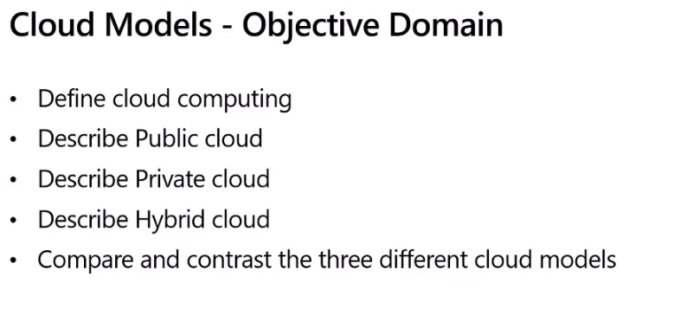

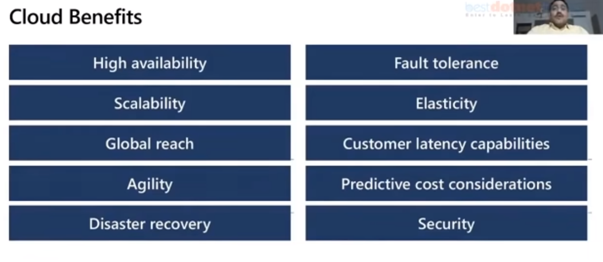

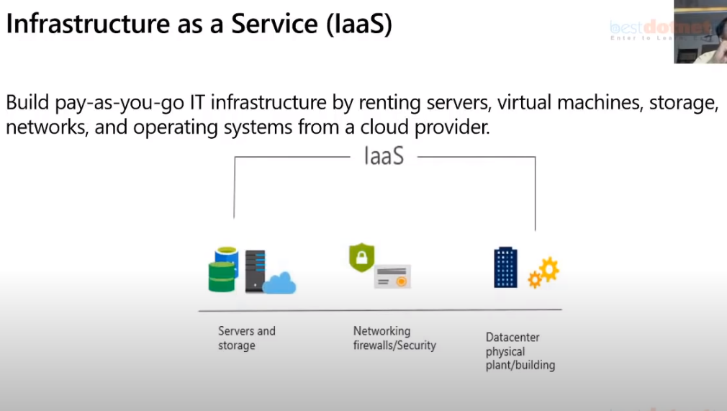

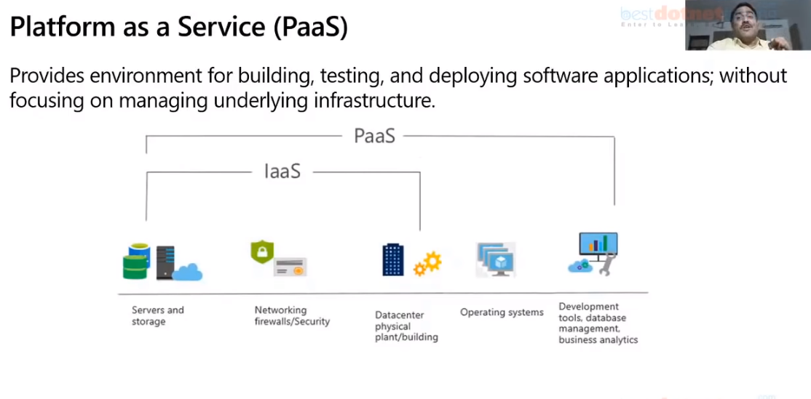

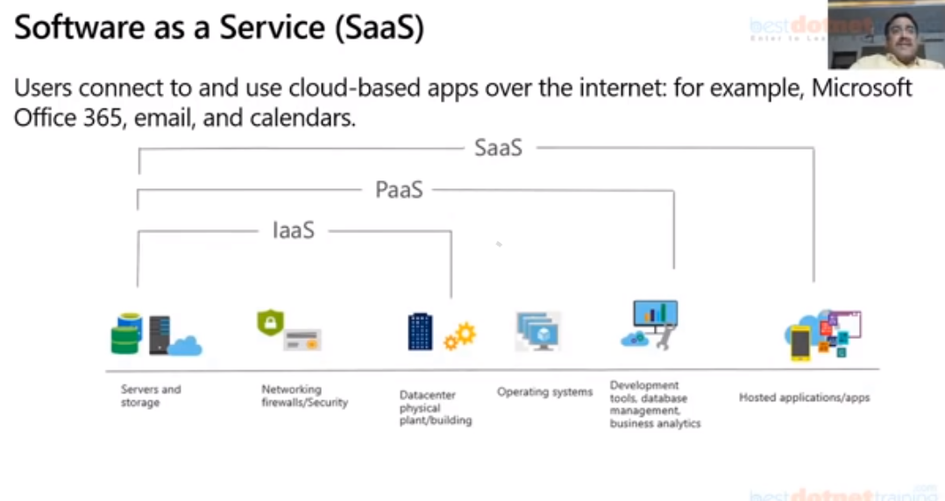

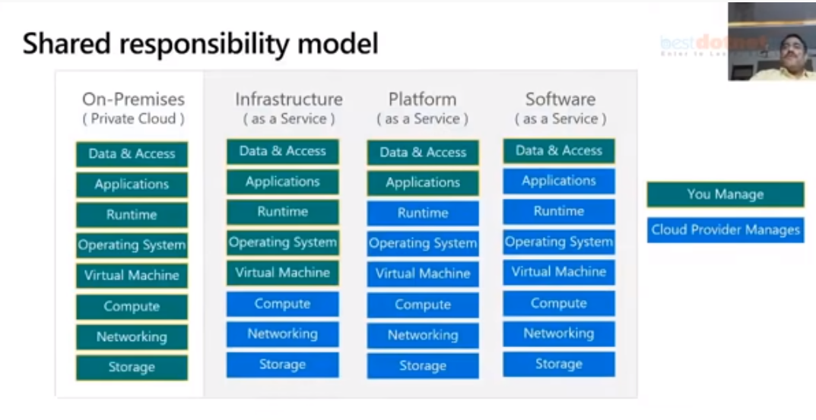

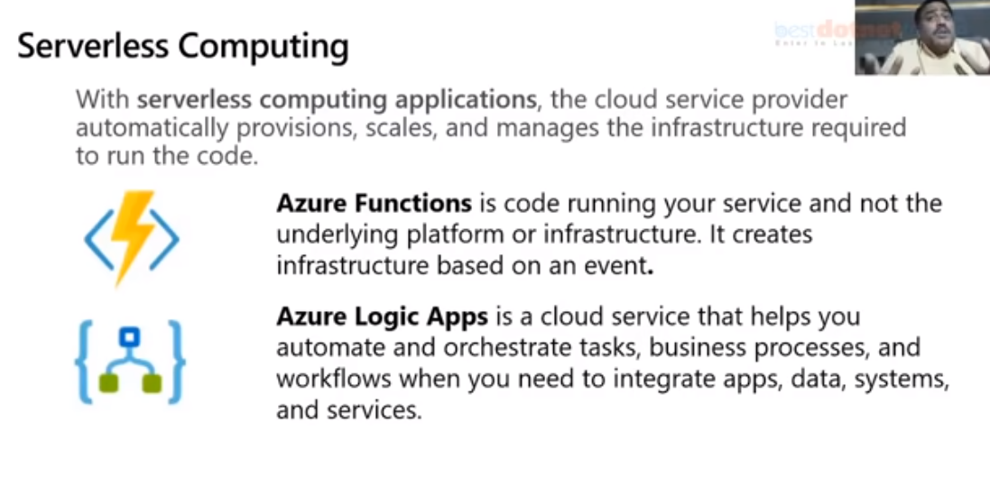

We still have the server but not reserved, but while only we[1] have execution request then servers are created.

1. **Azure Cloud**

   **Azure Is like OS which manages resources in World datacenters like OS in desktop.**

   **Divided in to regions in the world**

   **Each region will have zones.**

   **Regions required for high availabity, replication etc.**

   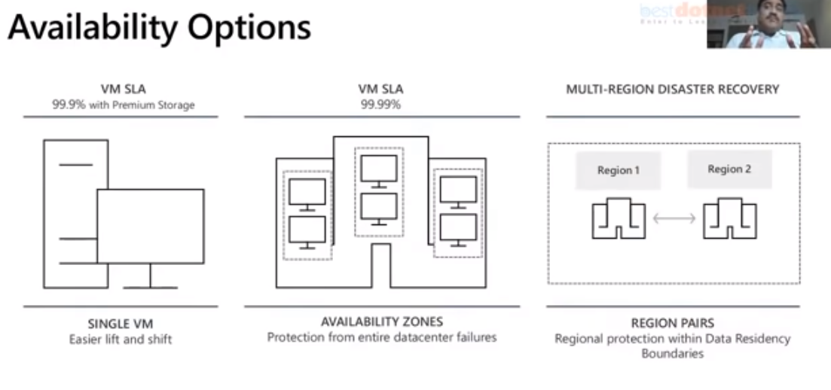

   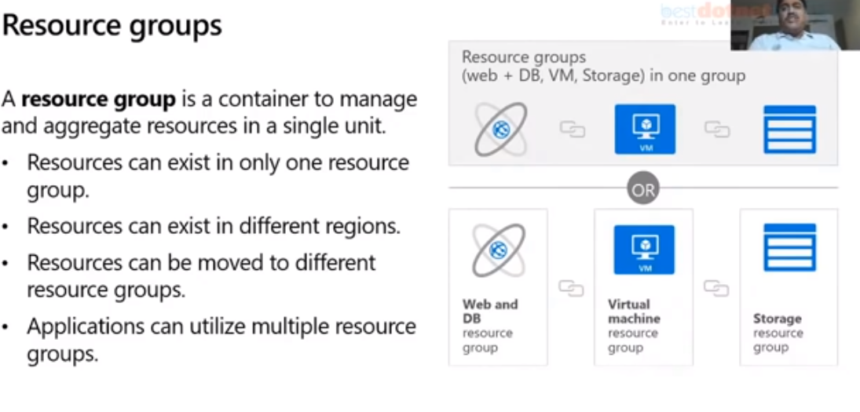

   Logical collection of resources, we can group all resources in one group, all Dbs. In one Resource group, one application-DB etc. can be grouped in one resource group. It’s our interest how to group or architect the resources. If resource group is deleted then all resources are deleted.

   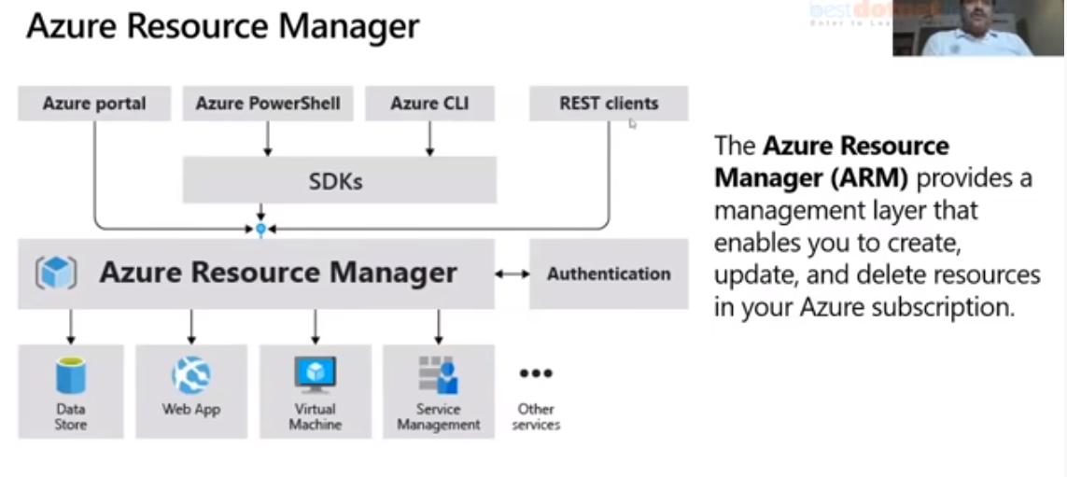

   **Jason document- ARM template.**

   Azure subscription is the container for the billing

   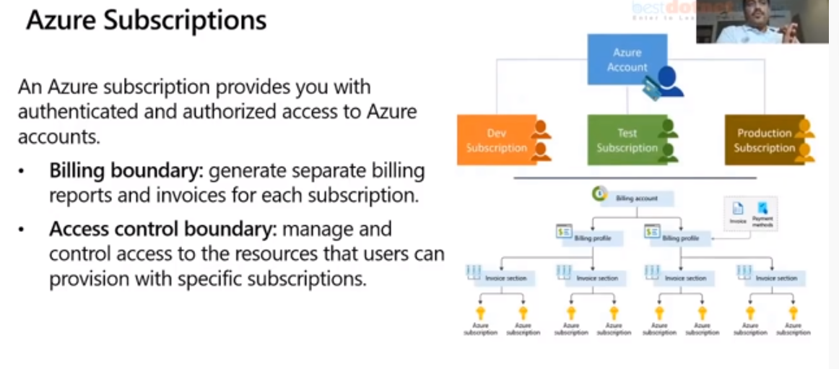

   Dev - one sub

   Prod- one sub.

   Marketing - one subscription.

   Hr. – One subscription.

   **Management group** is above subscriptions

   One Management group can have multiple subscriptions/Management groups.

   Policies, security can be attached to the management group.

   10000 MG can be created with in one account. 6levels possible

   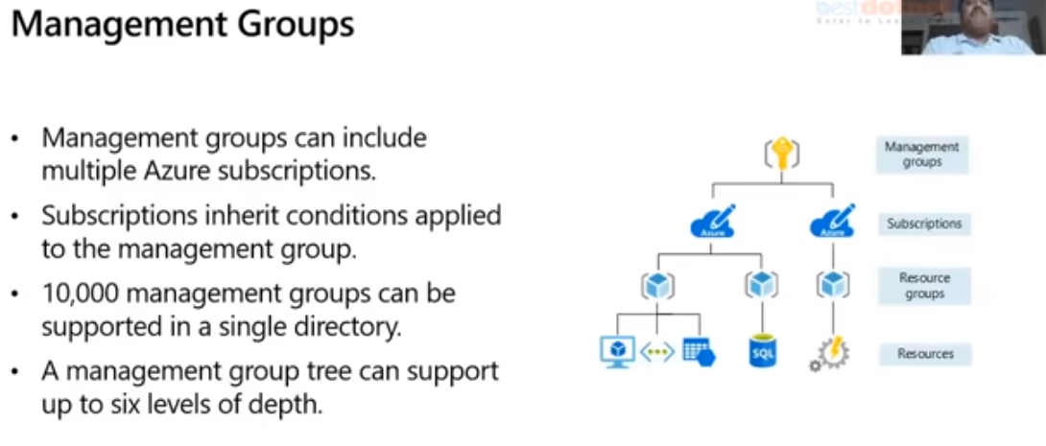

   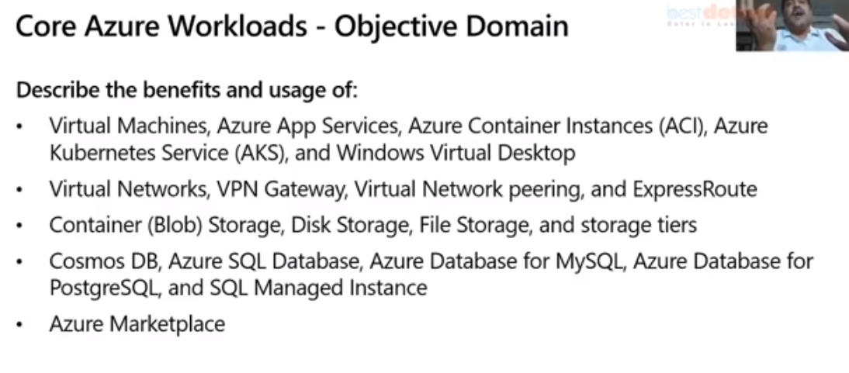

   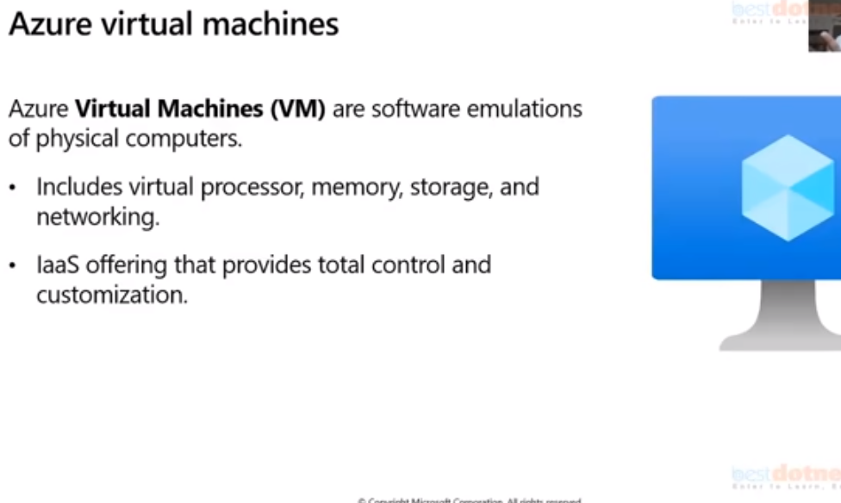

   **Acitivites:**

   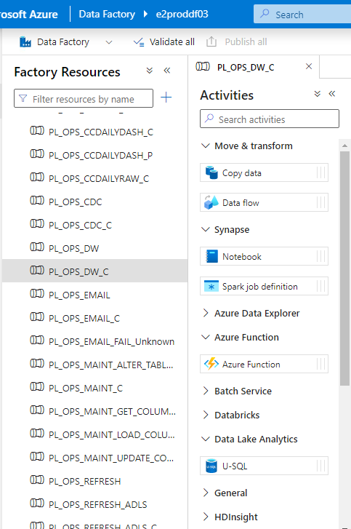

   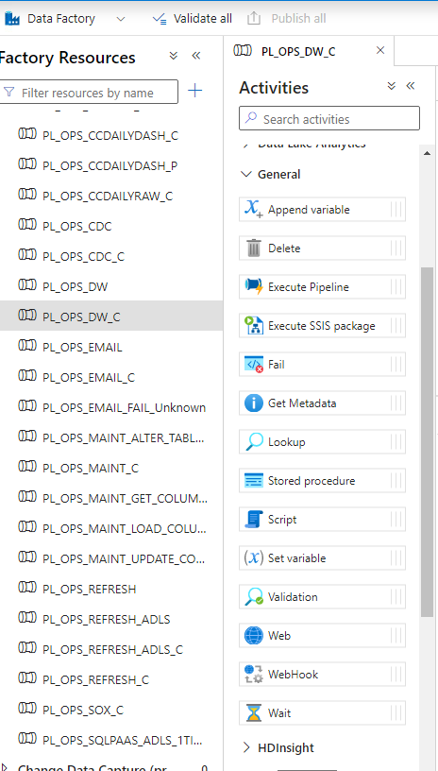

   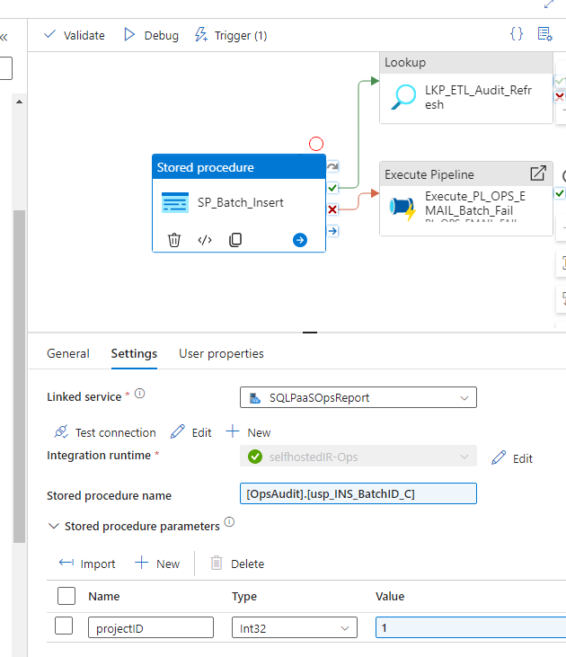

   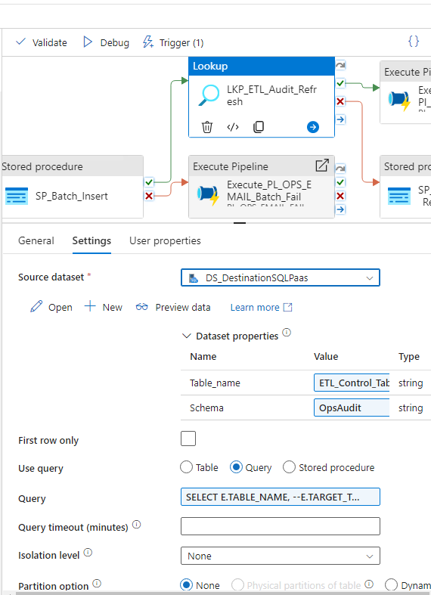

   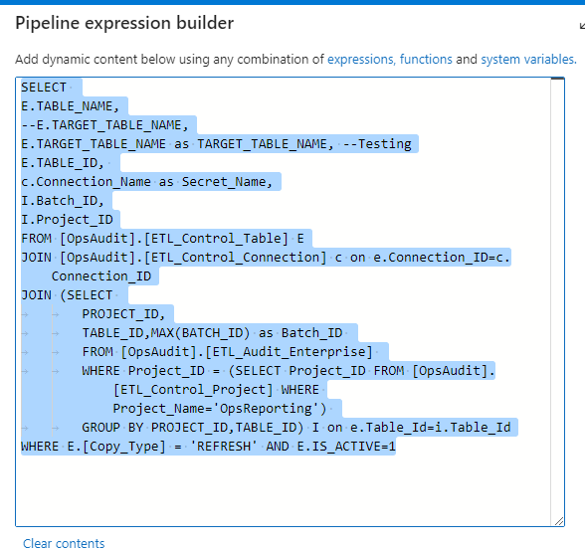

   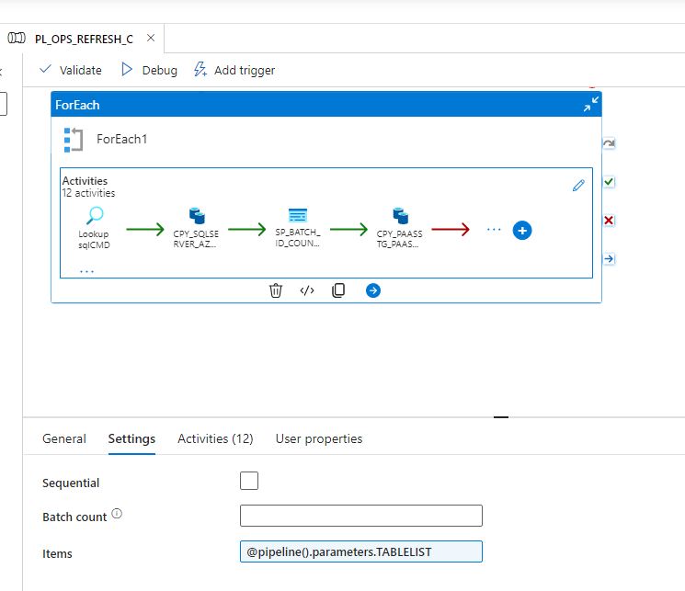

   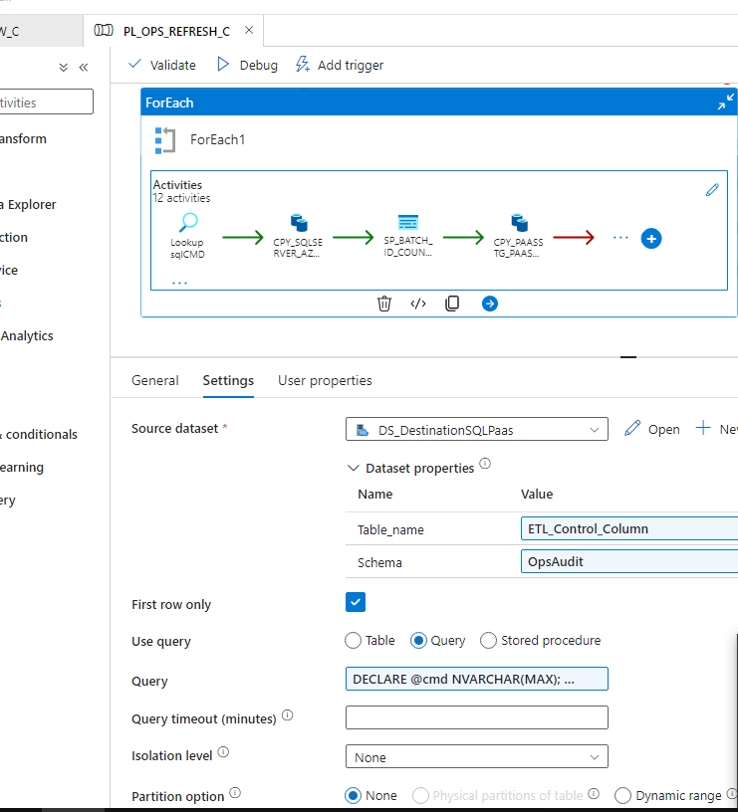

   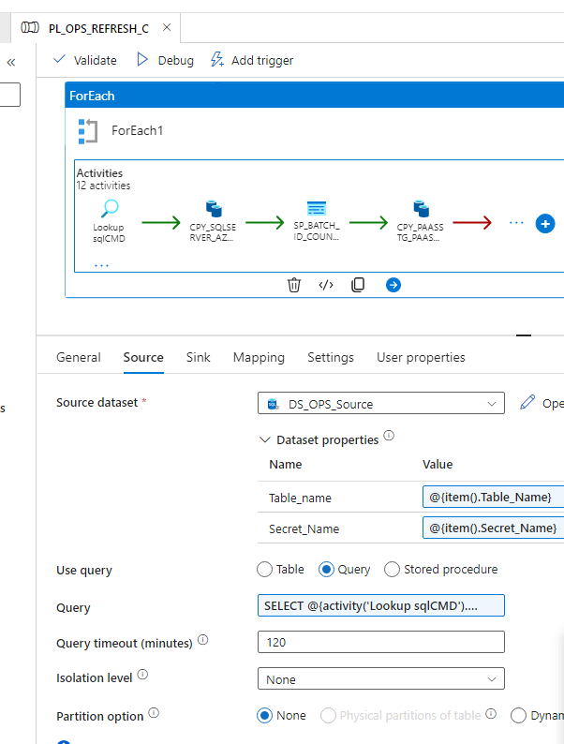

   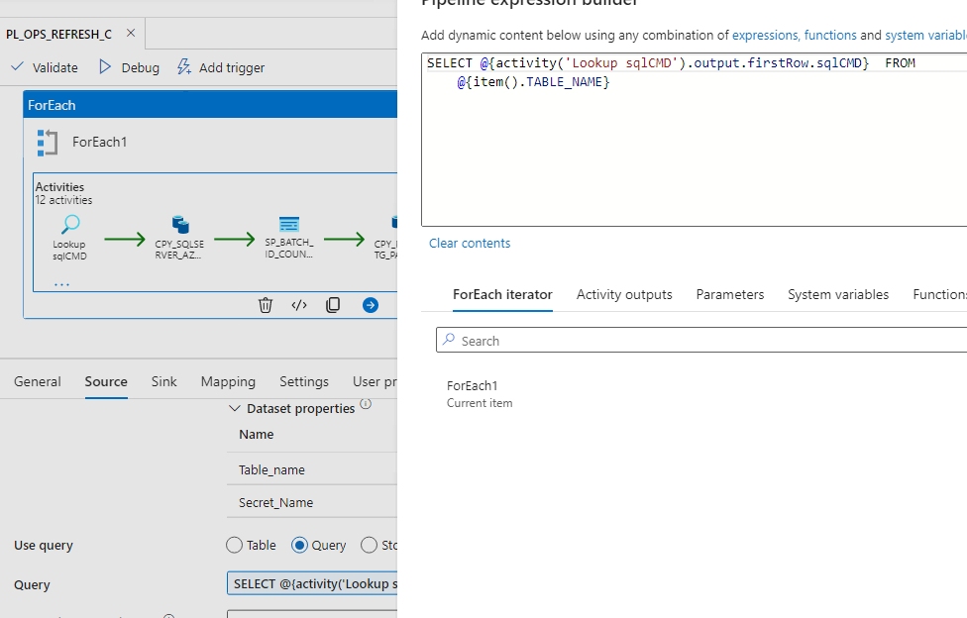

   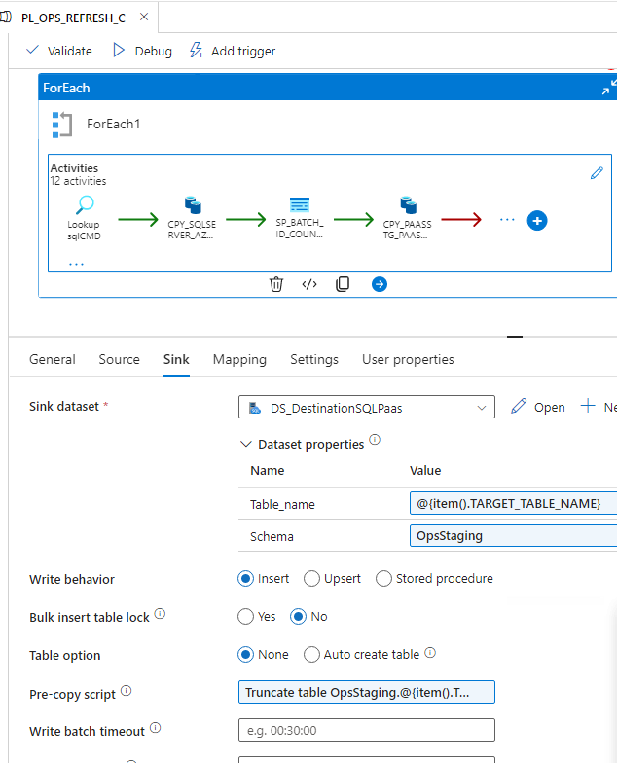

   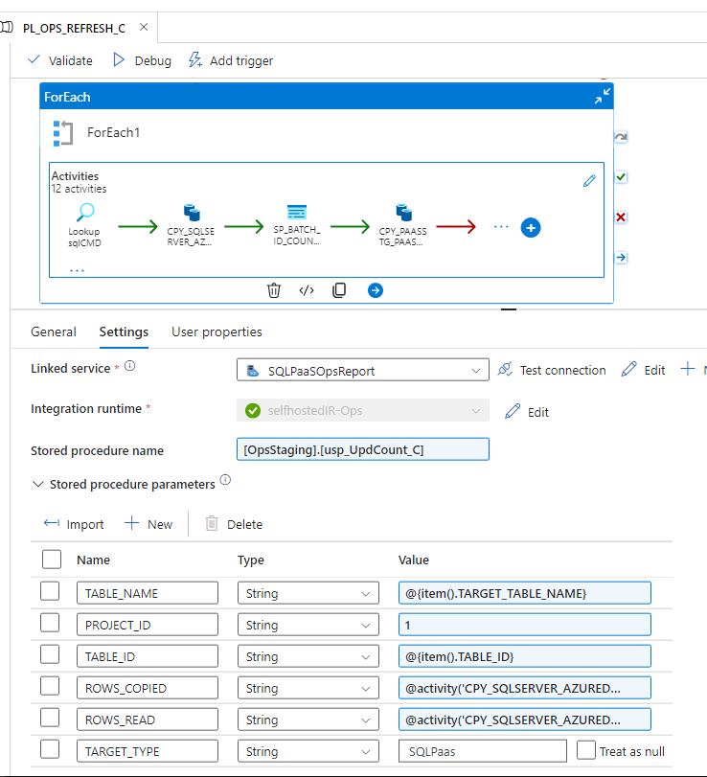

   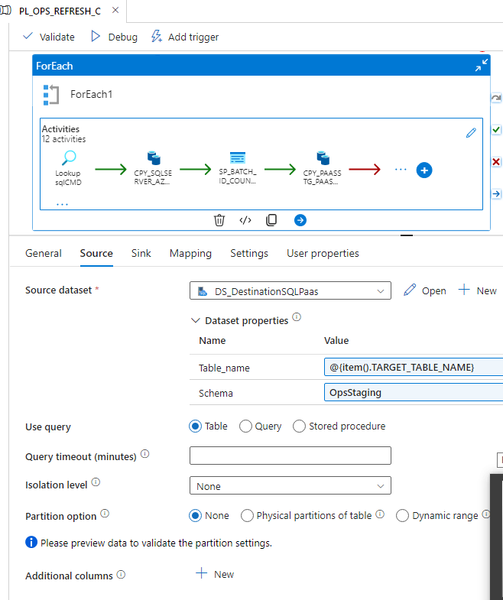

   Aaaaaaaaawlllll 